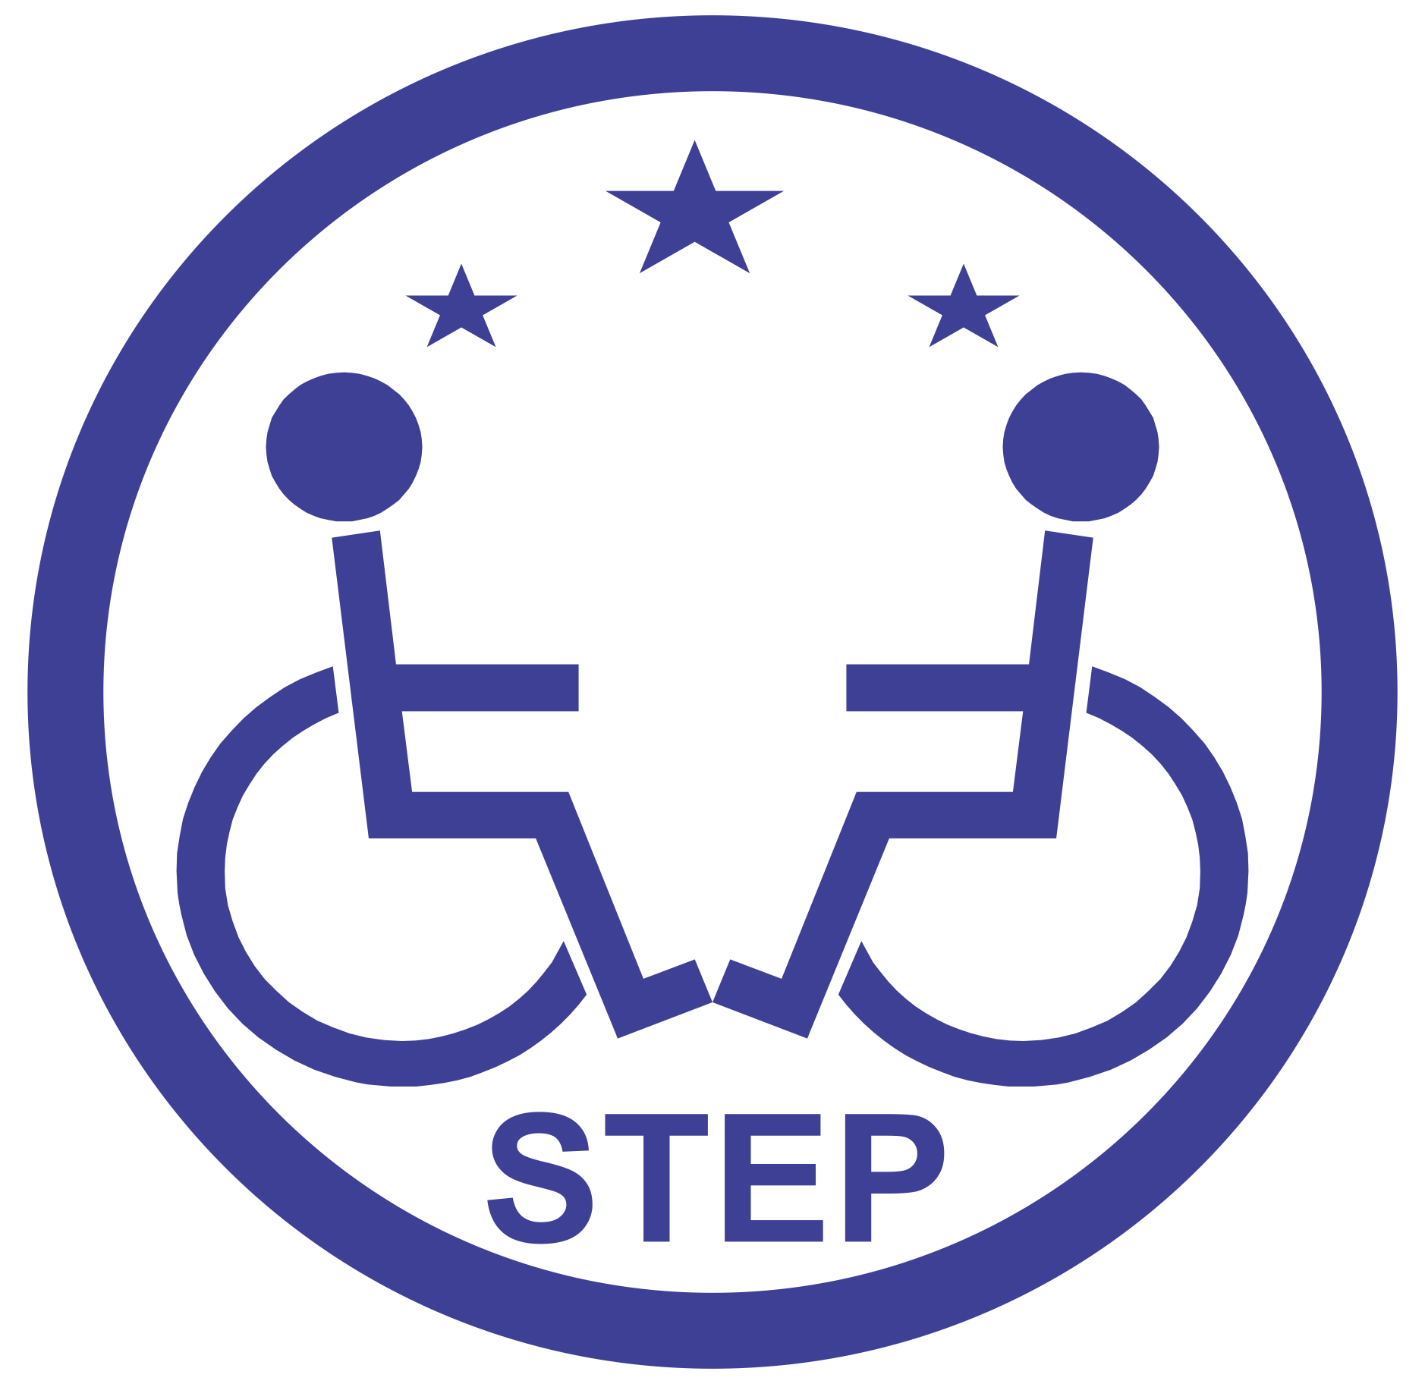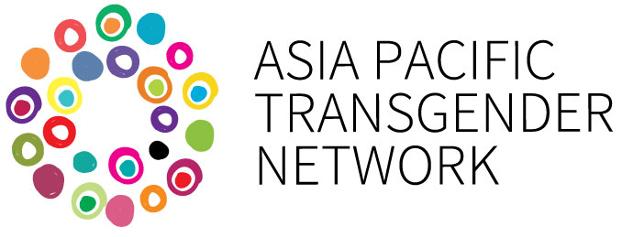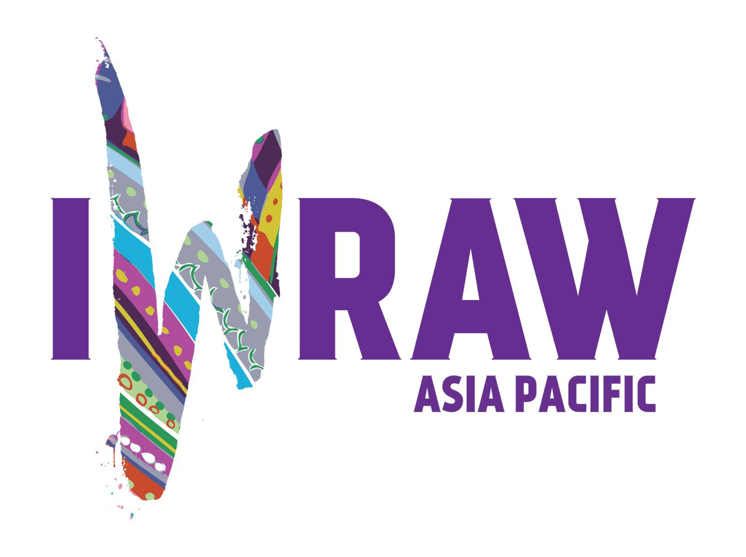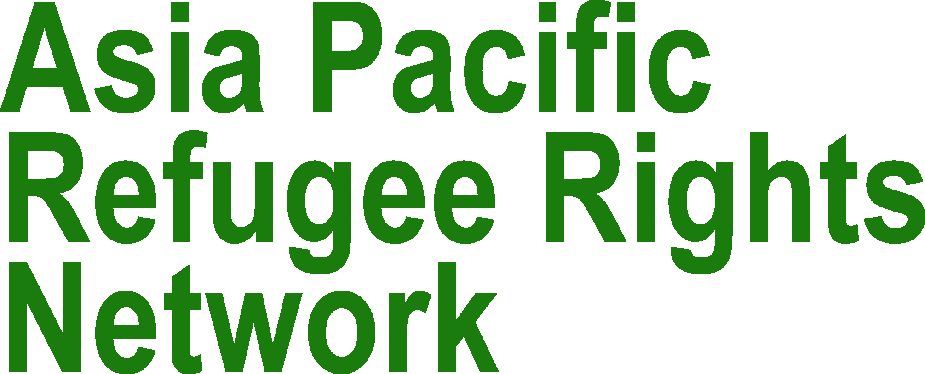

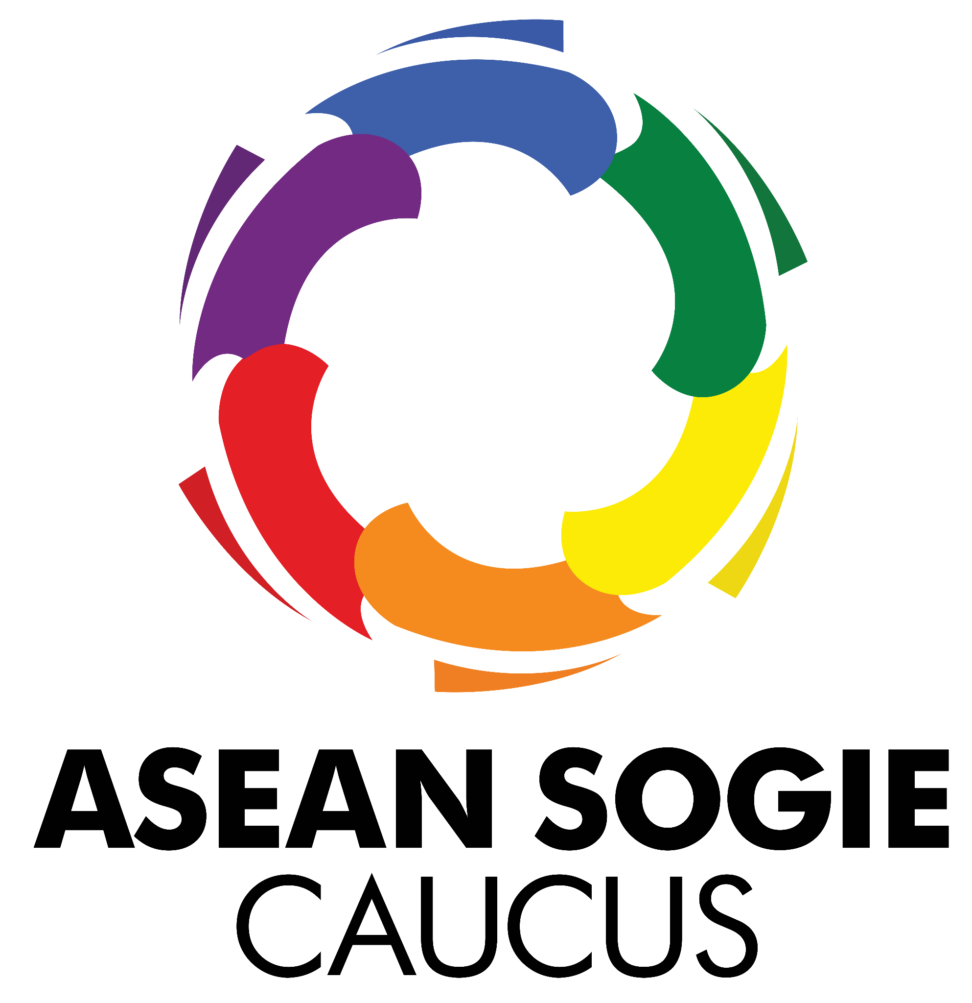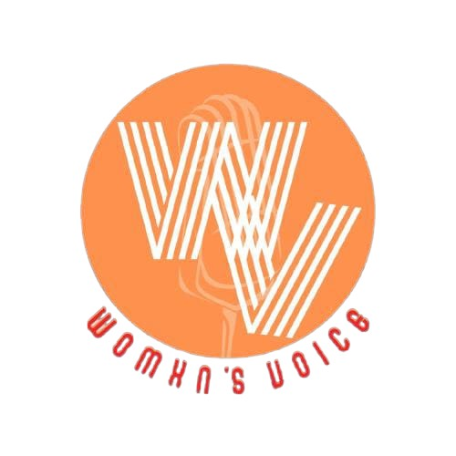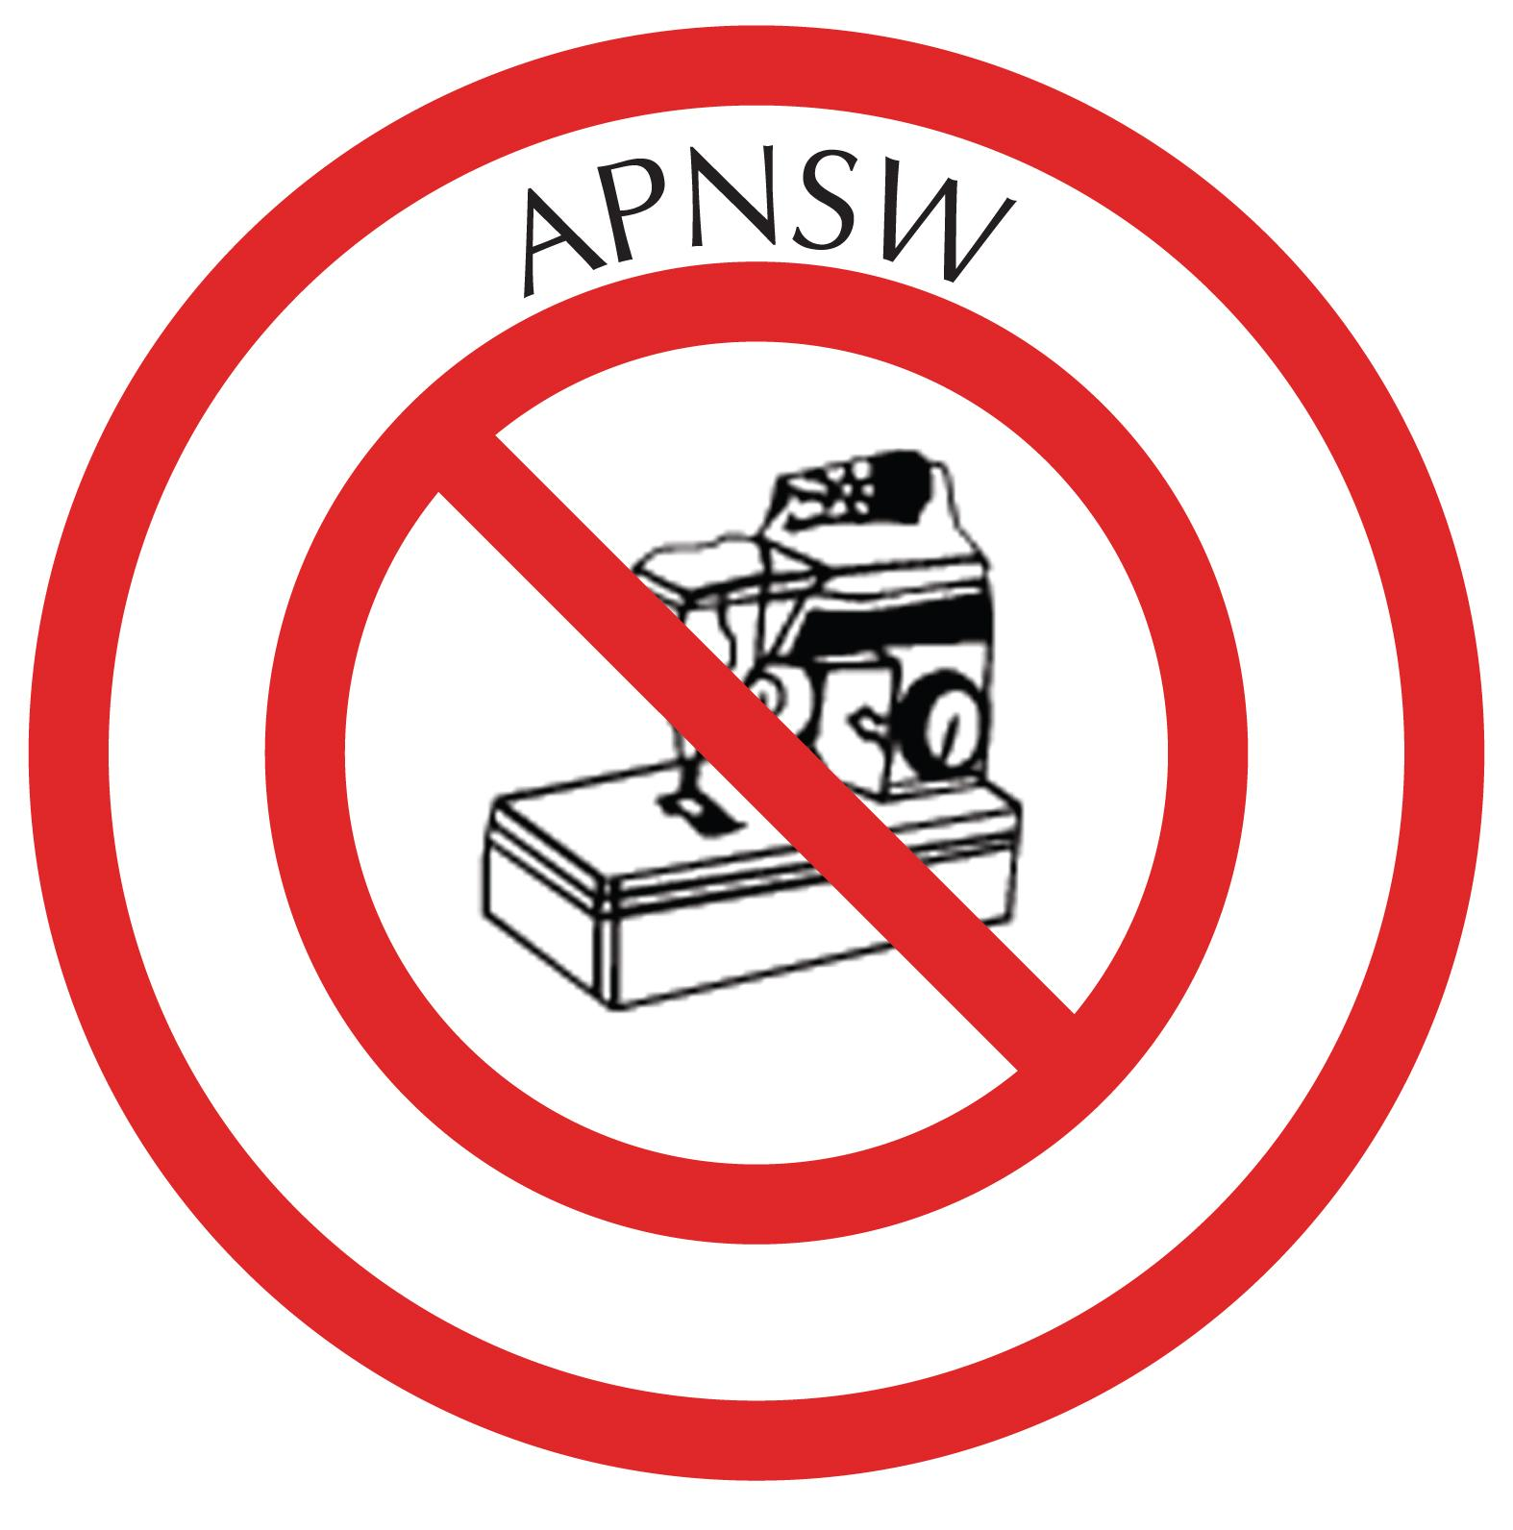

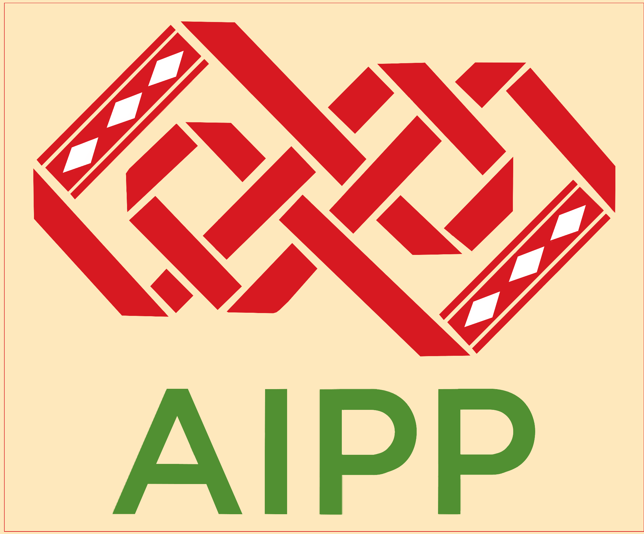

ASEAN SOGIE Caucus (ASC), Asia Indigenous People’s Pact (AIPP), Asia Pacific Network of Sex Workers (APNSW), Asia Pacific Refugee Rights Network (APRRN), Asia Pacific Transgender Network (APTN), International Women’s Rights Action Watch Asia Pacific (IWRAW AP), Special Talent Exchange Program (STEP), and Womxn’s Voice, as part of the Forging Intersectional Feminist Futures (FIFF) Consortium, would like to provide information to the CEDAW Committee on their upcoming general discussion on a new General Recommendation (GR) on equal and inclusive representation of women in decision-making systems, as the upcoming GR will provide guidance to CEDAW States parties on the measures that should be adopted to ensure full compliance with their obligations to respect, protect and fulfil women’s human rights.

**Introduction**

The FIFF Consortium was established to strengthen intersectional movement building in Asia that centers the voices and lived experiences of diverse groups of marginalised women and challenges multiple systems of oppression to achieve systemic gender equality. Thus, the FIFF Consortium supports the CEDAW Committee on its aim to shift the paradigm on women’s political leadership and participation in public and private sphere by establishing a new model of governance that is innovative, inclusive, representative, and harmonized framework that would provide *de jure* and *de facto* substantive equality specially to marginalized groups of women in leadership and decision making.

The joint submission of the FIFF Consortium will articulate the multidimensional barriers that marginalized groups of women face in their access to equal and inclusive representation in decision-making systems, and provide substantive recommendations in response to these barriers.

**Legal Recognition of Marginalised Groups of Women**

Marginalised groups of women face structural gender-based exclusion in decision-making spaces which deprive them of legal recognition **as women with unique, intertwining marginalized identities**. The lack of accessible legal recognition of [indigenous women](https://aippnet.org/wp-content/uploads/2021/06/AIPP-CEDAW-23June2021.pdf), [lesbian, bisexual, transgender and intersex (LBTI) women](https://weareaptn.org/resource/legal-gender-recognition-a-multi-country-legal-and-policy-review-in-asia/), [refugee women](https://www.unhcr.org/publications/brochures/61b28b734/meaningful-refugee-participation-transformative-leadership-guidelines-concrete.html), and [women with disabilities](https://asiapacific.unwomen.org/en/focus-areas/governance/womens-access-to-justice/disabilities) in all their diversity excludes them from public and private political processes, resulting in negative impacts to their everyday lives. Furthermore, [women sex workers](https://www.nswp.org/sites/default/files/sg_to_sw_as_experts_nswp_-_2020.pdf) and [women who use drugs](https://cndblog.org/2022/03/side-event-drug-policy-in-asia-the-importance-of-intersectional-perspectives/) experience varying forms of multiple and intersecting discrimination, which hampers and restricts them from participating in decision-making spaces especially on issues that concern them the most.

The non-recognition and exclusion of marginalized groups of women and girls in political spaces has also manifested in structural stigma, violence and exploitation perpetuated with impunity by both state and non-state actors.

*Recommendations*

As elaborated in CEDAW’s General Recommendation 28, it is the obligation of States Parties to eliminate **sex and gender-based discrimination** perpetuated against all women in all their diversity in all fields. The FIFF Consortium recommends to:

* **Recognise the expertise of marginalized groups of women,** including women sex workers and women who use drugs, in their access to rights-based health and social services, freedom from abuse and discrimination, and **self-determination**.
* **Ensure accessible access to legal gender recognition for transgender and intersex people, including transgender and intersex women and girls,** through the [principle of self-determination](https://yogyakartaprinciples.org/principle-31-yp10/) as articulated by the [IE SOGI’s report and legal opinion on legal gender recognition](https://d.docs.live.net/456347479b927f27/Documents/2016%20New%20York%20Declaration%20and%20the%202018%20Global%20Compact%20on%20Refugees%20(GCR)).
* **Uphold the realization of meaningful participation of refugee women in all their diversity** outlined in the 2016 New York Declaration and the 2018 Global Compact on Refugees (GCR) which calls for “states and relevant stakeholders [to] facilitate meaningful participation of refugees, including women, persons with disabilities and youth, in Global Refugee Forums, ensuring the inclusion of their perspectives on progress.”
* **Mandate the recognition of Indigenous women in their rights to citizenship, equality and non-discrimination within national constitutions, and their socio-political, economic and cultural rights through comprehensive legal frameworks and policy initiatives** including quotas for Indigenous women and girls in decision-making.

**Inclusive and Intersectional Gender-Responsive Infrastructures**

To shift the paradigm on equal and inclusive representation of marginalized groups of women in all their diversity in decision making, it is the obligation of States and non-States to **bolster investment in** [**accessible gender-responsive infrastructures**](https://www.unescap.org/sites/default/files/publications/SDD%20BDIS%20report%20A4%20v14-5-E.pdf) **including the mainstreaming and resourcing of accessibility** in public and private domains for safe, sensitive, and accessible environments, information, communications and technologies which are preconditions for meaningful participation of marginalized groups of women in decision making and political leadership.

Gender-responsive infrastructures also include the establishment of **implementable policies and programmes** that(a) **distribute the reproductive role of marginalised groups of women;** and (b) **respond to structural poverty and inequalities that they face**. By addressing the systemic issues and challenges that marginalised groups of women experience in their everyday lives through inclusive and intersectional gender-responsive infrastructures, it will now provide opportunities for them to meaningfully participate in leadership and decision-making processes.

*Recommendations*

To achieve inclusive, intersectional gender-responsive infrastructures, it is recommended to:

* Establish **mechanisms including temporary special measures for inclusive gender mainstreaming that provides resources for accessibility and reasonable accommodation** across the States Parties’ activities and programmes
* Ensure measures for the **distribution and valuation of the reproductive role relegated to women**
* Provide **accessible procedures in accessing the justice system** that is responsive to the different and unique forms of discrimination, stigma, and violence that marginalised groups of women and girls experience
* Adopt policies that provide **equal and *de facto* access of marginalised groups of women and girls to healthcare, education, employment, poverty alleviation and other social welfare** that is provided by States Parties, to ensure meaningful political participation.

**Countering Anti-Gender Narratives**

Anti-gender narratives and mobilising have intensified more than ever, and anti-gender actors have been infiltrating into and hijacking the political and decision making spaces across the world, including the UN human rights spaces in recent years. This has been [reported by the Working Group on Discrimination Against Women and Girls](https://www.ohchr.org/sites/default/files/Documents/Issues/Women/WG/Gender-equality-and-gender-backlash.pdf) in 2018 and discussed in the [Independent Expert on SOGI](https://documents-dds-ny.un.org/doc/UNDOC/GEN/G21/123/16/PDF/G2112316.pdf?OpenElement)’s report in 2021. However, just recently, the Special Rapporteur on Violence Against Women in her submission to the Scottish Parliament on the Gender Recognition Bill expressed her views that the Bill would allow “violent males who identify as men” to abuse the process and potentially risk the safety of women. This misleading claim was eventually [retweeted](https://twitter.com/DrAliceJEdwards/status/1619579182245347330) by the UN Special Rapporteur on Torture — a concerning watering down of established international human rights standards on gender and women’s rights, especially the right to freedom from discrimination, right to privacy, and right to self-determination. Furthermore, anti-gender actors have been influencing the drafting of human rights conventions by contesting the inclusion of gender as valid grounds for discrimination under international human rights law. During the negotiations for the Draft Convention on the Right to Development, some States opposed the inclusion of gender identity and sexual orientation, thus the [Intergovernmental Working Group on the Right to Development removed all references to them due to the assumed contested nature and legal status of the terms](https://www.ohchr.org/sites/default/files/2022-05/A_HRC_WG2_23_2_Add.1.pdf).

These attacks and misuse of gender and women’s human rights have detrimental unique and compounding impacts on marginalized groups of women, such as trans and intersex women, and gender diverse people who also use drugs, are refugees, sex workers, with disabilities, indigenous people, and with other marginalised status, given that experiences of discrimination based on intersecting marginalized identities cannot be dealt with as separate from one’s identity as a woman; this is also expressed in CEDAW’s General Recommendation 28. This prevalence has also sidelined the long-term and tireless effort of intersectional feminist movements to advocate for the gender-inclusive human rights standards. For an equal and inclusive representation of marginalized groups of women in decision-making, it is crucial that CEDAW, as a Convention that establishes international women’s human rights norms and standards, **to ensure that there is no place for anti-gender narratives nor regression on women’s human rights**.

*Recommendations*

CEDAW’s previous concluding observations, statements, general recommendations and decisions from the Optional Protocol have been consistent and strategic for marginalized groups of women in engaging their States Parties. It is recommended that:

* **CEDAW Committee remains steadfast in its commitment to protecting the rights of marginalized groups of women** experiencing multiple, intersecting and cumulative forms of discrimination. This includes Indigenous women; lesbian, bisexual, transgender, and intersex women; refugee women; women sex workers; women who use drugs; and women with disabilities, among others.
* The CEDAW Committee should remain open in embracing the concept of gender identity and expression in its work and advocate for mainstreaming the concept among UN Human Rights bodies.
* **Intersectionality is centered** in State obligations regarding women’s political leadership and participation in decision-making.

**Equal and Inclusive Gender Data**

The CEDAW Committee has consistently requested States Parties to provide sex-disaggregated data in their State Reporting to the CEDAW State Review. However, sex-disaggregated data only captures a homogenous overview of women’s political situation, not taking into consideration the complexities and disparities that marginalized groups of women experience in relation to State obligations to CEDAW. As an articulation of a shift in the paradigm of women’s political participation, the CEDAW Committee Members should take into consideration more [comprehensive, intersectional and inclusive sex and gender data](https://data-feminism.mitpress.mit.edu/pub/h1w0nbqp/release/3) that addresses other marginalized identities of women in local, regional, national and international leadership and decision-making spaces.

*Recommendations*

* **Monitor equal and inclusive gender data** on the situation of marginalized groups of women such as but not limited to Indigenous women; lesbian, bisexual, transgender and intersex women; older women; refugee women; women sex workers; women who use drugs; and women with disabilities, among others.
* **Provide capacity building and strengthening sessions on equal and inclusive gender data generation** in local, regional, national and international leadership and decision-making spaces responsive to the realities of marginalized groups of women.
* **Implement** **quotas and temporary measures** for marginalized groups of women to foster meaningful participation in decision-making spaces.
* **Generate** **data on reasonable accommodation** in leadership and decision-making spaces for marginalized groups of women.

**Retrogression, Reprisals, and Shrinking Civic Space for the Feminist and Human Rights Movement**

Experiences of retrogression, shrinking of civic space and State-sponsored reprisals through [red-tagging](https://www.facebook.com/photo?fbid=491014413069677&set=a.230312495806538) of marginalized groups of women human rights defenders have been prevalent over the years. These have included the introduction of [disciplinary laws and practices including anti-terrorism and anti-defamation laws, militarization and attacks against journalists, human rights defenders, Indigenous people and activists, while growing nationalism and authoritarian deployment of ‘national security’ discourses, closely linked to religious fundamentalisms, have perpetuated racism, whorephobia, and anti-gender narratives](https://www.iwraw-ap.org/resources/reflexion-paper/).

Online inclusive and accessible spaces have also been a political space of [control and violence against marginalized groups of women](https://fma.ph/2021/11/04/the-modern-age-of-filipino-feminism-digital-activism-social-media-and-gendered-disinformation/) perpetuated by State and non-State actors. Since the outbreak of the pandemic, [organised machinery of misinformation and a culture of online hate speech and misogyny](https://asiapacific.unwomen.org/en/digital-library/publications/2021/04/eliminating-online-hate-speech-to-secure-women-s-political-participation) have intensified. It is the obligation of States Parties of the Convention to ensure that even in online spaces, women in all their diversity have the right to a safe and enabling digital space to organize, advocate and respond to political issues concerning women’s human rights.

*Recommendations*

* Monitor whether newly established disciplinary laws are harmful and violate women’s human rights established by the CEDAW Convention and other international human rights bodies.
* Provide temporary measures including quotas on Women, Peace and Security (WPS) national plans and implementation that covers online and offline spaces and ensures the meaningful participation of marginalized groups of women in all levels of decision-making.
* Ensure that State and non-State actors disincentivize social media algorithms that profit from gendered stereotypes and disinformation.
* Provide measures for State and non-State actors including social media platforms to combat discriminatory information online against women and girls.
* Provide avenues for States and non-State actors to engage and collaborate with NGOs and CSOs led by and for marginalized groups of women, to achieve inclusive, participatory, and meaningful political participation of women in enacting and implementing laws that impact their everyday lives.
* Online Gender Based Violence (GBV) is systemic and stems from an unequal distribution of power and resources.Women are 27 times more likely than men to be harassed online and almost three quarters of women have experienced some form of online violence. The power structures that uphold and protect perpetrators of GBV, as well as the acts of violence, must be addressed.