CEDAW Committee Elections Update

February 2021

State parties to the UN Convention on the Elimination of All Forms of Discrimination Against Women elected 11 new members to the UN CEDAW Committee on 9 November 2020. The election of UN treaty body members is a crucial, foundational process for ensuring protection of rights holders. All stakeholders, particularly civil society organisations, should pay deeper attention and engage with this process both at the national and international levels. The lack of transparency around the nomination and election processes in general is detrimental to active civil society participation, and consequently excludes rights holders themselves from this critical process. States and relevant UN bodies, particularly the Office of the High Commissioner for Human Rights (OHCHR), must consider strategies to address this challenge.

**Geographic distribution[1]**

Nineteen countries nominated candidates for election to the CEDAW Committee. A breakdown of the candidates by the geographical regions they represent is below:

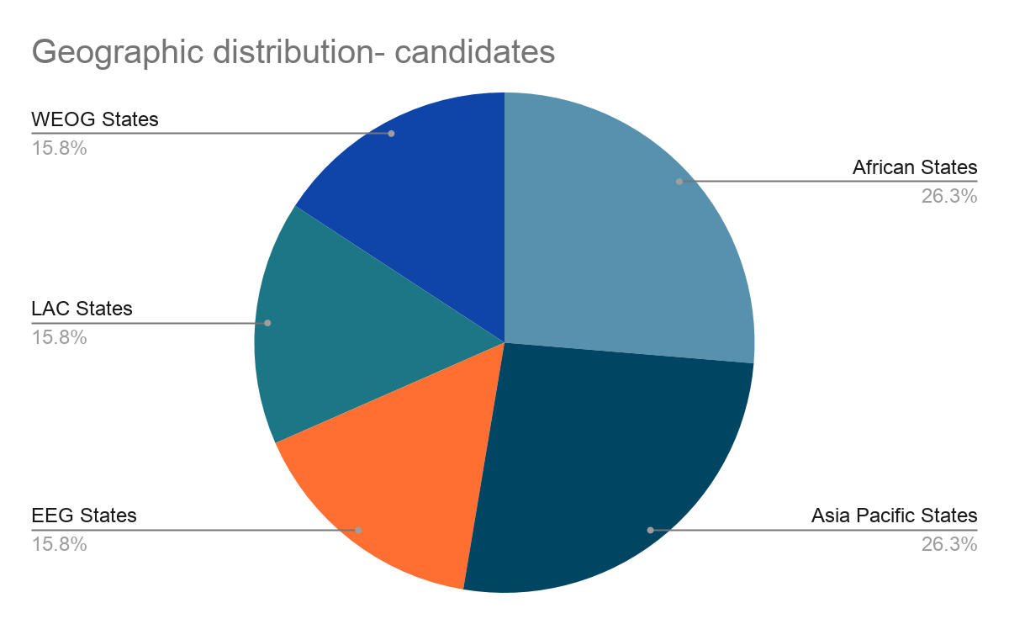

The eleven members elected to the CEDAW Committee are from Australia, the Bahamas, China, France, Ghana, Lebanon, Lithuania, Mexico, Nepal, the Netherlands and the Philippines. A breakdown of the elected members by the geographic regions they represent is below:

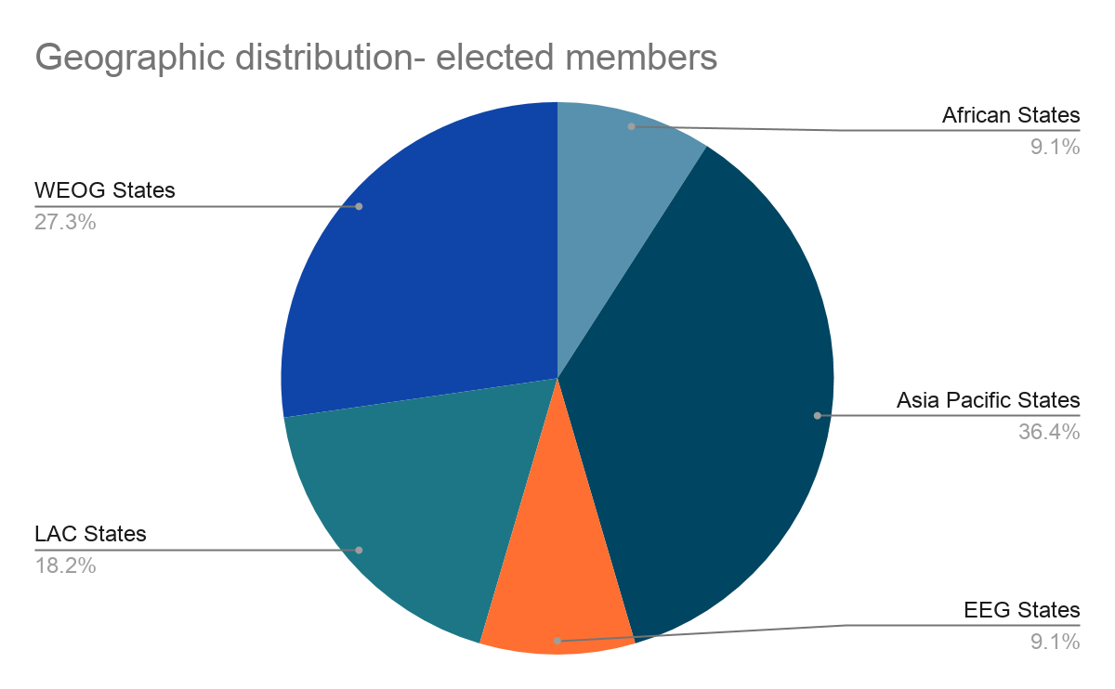

Whereas States must give due consideration to issues of geographical distribution in the composition of UN treaty bodies, it is unfortunate that in practice there continues to be a wide imbalance in representation.[2] The current election of the CEDAW Committee will continue the trend of the acute underrepresentation of African States on the Committee and the overrepresentation of Eastern European States and Western European & Other States.

From January 2021, the geographic distribution of the membership of the CEDAW Committee is as follows:

|  |  |  |  |  |
| --- | --- | --- | --- | --- |
| Region | Number of members | Percentage | Number of ratifications | Percentage |
| **African States** | 5  [Algeria, Burkina Faso, Egypt, Ghana, Mauritius] | 21.7% | 52 | 27.5% |
| **Asia Pacific States** | 6  [China, Japan, Lebanon, Nepal, Philippines, Saudi Arabia] | 26.1% | 51 | 27% |
| **Eastern European States** | 4  [Azerbaijan, Bulgaria, Georgia, Lithuania] | 17.3% | 23 | 12.2% |
| **Latin American & Caribbean States** | 4  [Bahamas, Mexico, Peru, Trinidad & Tobago] | 17.3% | 33 | 17.5% |
| **Western European & Other States** | 4  [Australia, France, Netherlands, Spain] | 17.3% | 28 | 14.8% |
| **Non-member States** |  |  | 2 | 1.1% |

**New and re-elected members**

Four members have been newly elected to the CEDAW Committee. The remaining seven appointees are sitting members of the CEDAW Committee who have received new terms. A breakdown of the elected members by terms is below:

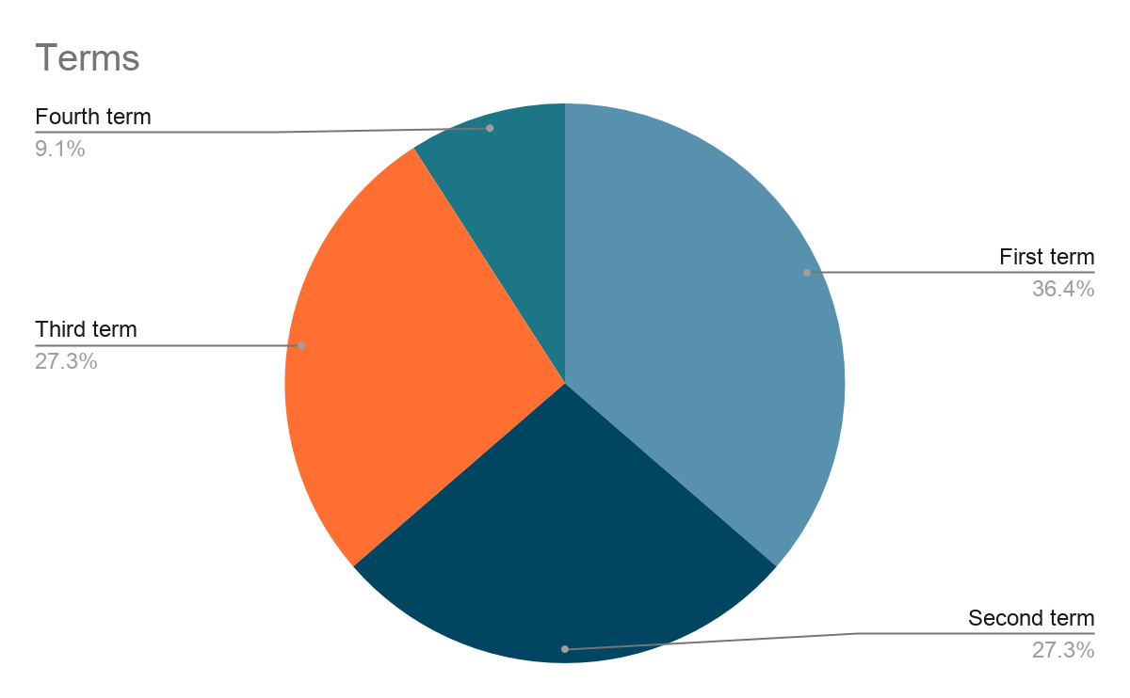

The CEDAW Committee is one of seven treaty bodies whose rules of procedure do not specify term limits for its members. All stakeholders must give regard to the issues that arise from the lack of term limits, including an adverse impact on the equitable geographic distribution in the composition of the UN treaty bodies as well as the absence of opportunities for the UN treaty bodies to benefit from new and dynamic viewpoints.

1. The geographic distribution of the UN is as follows: African States, Asia Pacific States, Eastern European Group (EEG) States, Latin American & Caribbean (LAC) States and Western European & Others Group (WEOG) States.
2. Promotion of equitable geographical distribution in the membership of the human rights treaty bodies: resolution adopted by the General Assembly, A/RES/74/155, 20 January 2020.