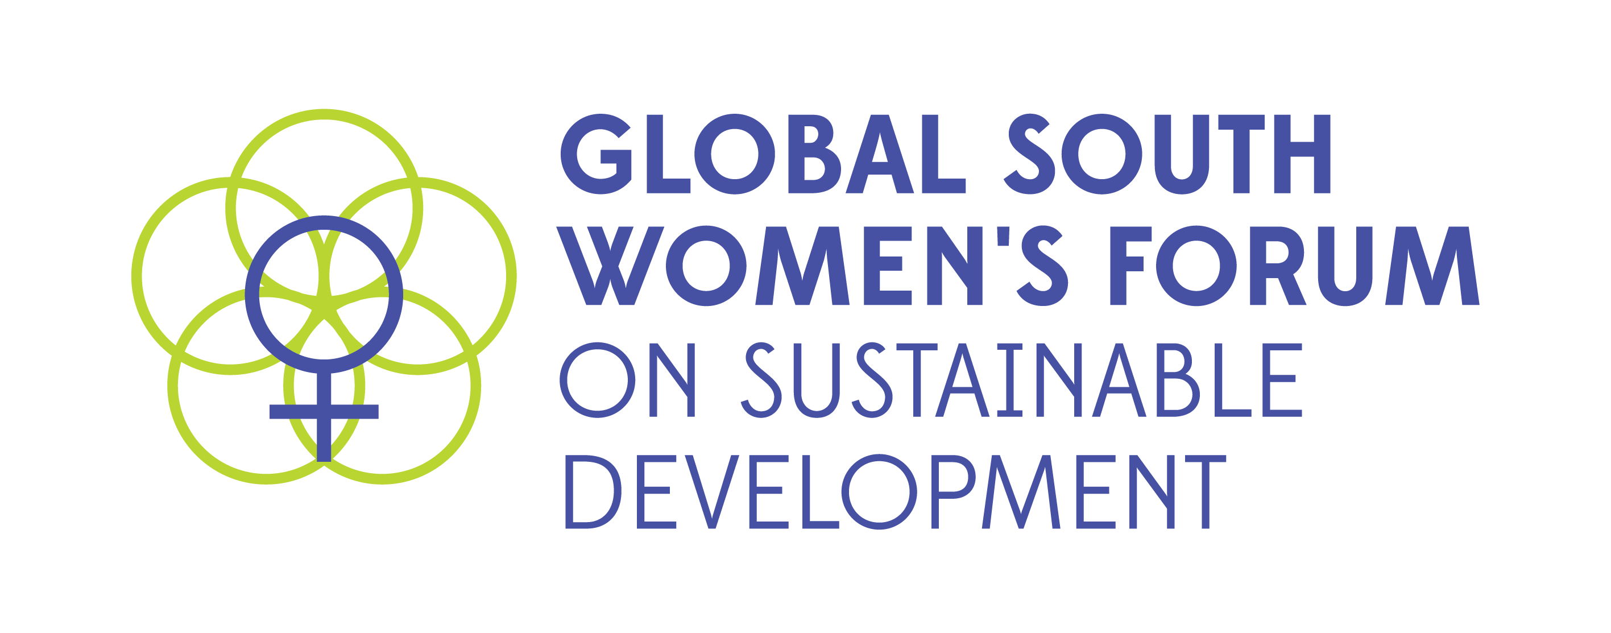

**GSWF 2020 Proposal Submission Form**

**Deadline for submission: 12 November 2020**

Selected proposals will be advised by 20 November 2020

IWRAW Asia Pacific is inviting proposals to develop and lead thematic sessions at this year’s virtual Global South Women’s Forum on Sustainable Development, 14-18 December 2020. This invitation includes proposals from artists who are interested in showing their work, organising a virtual performance, or incorporating artistic creation into a session.

Before submitting this form, please refer to our blog post, [Global South Women’s Forum 2020: Disrupting Macroeconomics](https://www.iwraw-ap.org/gswf2020/), for more information on this year’s theme.

**GSWF 2020 Theme**: Feminist macroeconomics, power, and justice

**GSWF 2020 Forum Objectives**:to host an online space that:

1. enables vibrant exchanges of knowledge and expertise among participants with different perspectives and lived experiences;
2. facilitates the co-creation of strategies for ensuring accountability among states and other actors, including developing alternative policy approaches and advocacy demands;
3. fosters cross-movement building and solidarity for sustained action;
4. celebrates the gains, resilience, and joy of feminist organising and advocacy; and
5. brings together individuals and groups who can speak to the impact of economic policy changes on the lived realities of women in their countries; have spent time analysing related policy and legal trends; and/or have ideas for policy alternatives or innovative ways to transform macroeconomics into a tool for advancing women’s human rights and gender equality.

Proposals from all policy, organising, or activist backgrounds are strongly encouraged. A formal organisational mandate or professional background in macroeconomic policy is not required. Please refer to the selection criteria below for more information.

**Session Proposal Objectives (please highlight all applicable options)**

* Knowledge exchange and capacity building
* Develop advocacy strategies and alternative policy demands
  + Invite-only / Public **(please delete as inapplicable)**
* Creative expression and artistic sharing
* Cross-movement and solidarity building
* Other objectives identified by session organisers (kindly provide a short description in the space below)

|  |
| --- |
|  |

**Session Formats (please highlight all applicable options)**

* Talks and training workshops
* Film screenings
* Art co-creation, poetry readings, reading groups, and so on
* Music events
* Podcasts or other audio sessions
* Thematic ‘ask anythings’
* Short sessions of 10-30 minutes (proposals for pre-recorded sessions can be submitted under this category)
* Other (we welcome applicants’ proposals for other format ideas. Kindly provide a short description in the space below)

|  |
| --- |
|  |

**Examples of policies relating to gender equality and macroeconomics**

To encourage proposals from diverse groups of women’s rights advocates with varying experience in macroeconomic policy making, we provide here some examples of policies that have been and are being explored by feminists and women’s rights scholars, activists, and practitioners. This list is not exhaustive. We welcome sessions that focus on other areas relating to gender equality, women’s human rights, and macroeconomics.

Our examples are: tax policy and budgets; paid and unpaid care work and/or the care economy as a whole; labour flexibilisation; privatisation; commodification of public goods; access to financial services; illicit financial flows; financing development; the growing role of banks, investors, and other financial actors and instruments in global and national economies (sometimes discussed under the umbrella of ‘financialisation’); trade and foreign investment; private and public debt; capital flight; global supply chains, corporate accountability, and/or corporate capture; and other advocacy or policy areas relating to the global economic architecture and its impact on women’s human rights and gender equality.

**Selection Criteria**

Below, we have identified selection criteria that will be considered in evaluating session proposals. These descriptions are not exhaustive. If you have any questions or uncertainties about whether to submit a proposal, please do not hesitate to contact us at [gswf2020@iwraw-ap.org](mailto:gswf2020@iwraw-ap.org) (with a copy to [constanza@iwraw-ap.org](mailto:constanza@iwraw-ap.org)).

We are inviting proposals from diverse feminists and social justice activists, organisers, artists, and practitioners from across the Global South to lead and develop sessions. We are particularly interested in hearing from people [representing marginalised groups or advocating for underrepresented issues](https://www.iwraw-ap.org/wp-content/uploads/2018/07/IWRAW-Asia-Pacific-Policy-on-Addressing-Rights-of-Marginalised-Groups-of-Women.pdf).

Proposals are welcome from Global South women-led organisations; activists and organisations with clear links to national or grassroots movements or groups; feminist organisations; community-led networks and organisations; researchers, academics, and practitioners; women’s rights activists and organisations; and other justice-oriented groups, such as those working on racial justice, labour rights, environmental justice, migrant rights, Indigenous rights, disability rights, and the rights of LBTQ women and intersex persons. Proposals are also welcome from artists who are interested in showing their work, organising a virtual performance, or incorporating artistic creation into a session.

Women’s rights activists from all policy, organising, or activist backgrounds are strongly encouraged to submit proposals. A formal organisational mandate or professional background in macroeconomic policy is not required. Part of the purpose of GSWF 2020 is to disrupt conventional constructions of economic ‘experts’ and to bring together individuals and groups whose experience contributes to the GSWF 2020 theme and objectives identified above.

Priority will be given to proposals that apply an intersectional feminist approach to their sessions, particularly those combining feminist economic justice analysis with anti-racist, anti-colonial, and anti-imperialist frameworks and demands, including those that specifically address anti-Blackness.

We also encourage sessions that explore the interplay between global economic actors, such as the International Monetary Fund (IMF), World Bank, and other international financial institutions, and national-level policy making. Sessions that incorporate participatory and interactive methodologies will also be strongly considered.

**Session Title (max. 75 words)**

|  |
| --- |
|  |

**Main Contact Person (name, organisation or affiliation, email address, and phone number)**

|  |
| --- |
|  |

**Duration (max 1.5 hours)**

|  |
| --- |
|  |

**Session Proposal (max 500 words).** The description should include key objectives (what you hope to achieve), an explanation of the connection between the proposal and [GSWF 2020 theme and objectives](https://www.iwraw-ap.org/gswf2020/), identify how the session will promote intersectionality and inclusivity, and describe the methodology or format, including any interactive or participatory tools or approaches that will be used.

|  |
| --- |
|  |

**Language(s) of Session**

|  |
| --- |
|  |

**Geographical Focus**

|  |
| --- |
|  |

**Preferred Time Zone for the Session**

|  |
| --- |
|  |

**Other Proposed Organisers, Speakers, Facilitators, Performers, etc. (names and organisations or affiliations).**

Exact details can be confirmed after successful application.

|  |
| --- |
|  |

**Funding.** Please indicate whether you or your organisation may be able to either partially or fully fund your participation in GSWF 2020. This information will not impact our consideration of the proposal but may help us to host more sessions by allocating available financial resources to those who do not have access to funding. Please see the ‘Funding’ section below for more information.

|  |
| --- |
|  |

**Documentation.** Please indicate how you expect to document the outcomes or outputs of your session and share them more broadly, including with IWRAW Asia Pacific. We also note that, if possible, transcriptions of sessions and subtitles for videos are a welcome addition for enhancing accessibility before and after the event. IWRAW Asia Pacific anticipates that documentation of sessions throughout GSWF 2020 will be used to create a compilation document and/or video accessible on our website.

|  |
| --- |
|  |

**Accessibility**

Please let us know whether support is required for one or any of the following to facilitate your participation in GSWF 2020:

* **Translation/Interpretation**. If required, please indicate below the languages that require translation or interpretation and whether you will arrange your translators or interpreters or would like IWRAW Asia Pacific to help with these arrangements.

|  |
| --- |
|  |

* **Connectivity and caregiving**. Please indicate below if you require support relating to getting online including, for example, internet top-ups or timing considerations relating to caregiving responsibilities. If yes, information on how to apply for funding, if needed, is provided in the ‘Funding’ section below.

|  |
| --- |
|  |

* **Access needs**. Please indicate below any support that may be required to facilitate participation of organisers, facilitators, speakers, performers, or participants with disabilities. We would also be happy to discuss in a voice call or videoconference if preferred.

|  |
| --- |
|  |

* **Security needs**. Please indicate below any security concerns relating to organisers, facilitators, speakers, performers, or participants, and any requests for measures to address those concerns. For example, password protected or invite-only sessions, etc.

|  |
| --- |
|  |

**Funding**

Organisers who require funding for their session are encouraged to submit a budget outlining anticipated costs, up to a maximum of $2,500. Eligible costs include:

* Connectivity costs, such as the cost of data top-ups, travel to internet cafes, and/or cost of childcare or other services to allow for participation during the session
* Security-related costs, such as purchase of virtual private networks (VPNs)[1]
* Research and other session preparation costs
* Costs of materials for session, particularly those relating to documentation or connected to artistic performances
* Cost of meals on the day of the session

Funding for selected proposals is not guaranteed, nor is the maximum amount of $2,500. If provided, the amount of funds may depend on the volume of applications. If you have any questions, please do not hesitate to contact us at the email addresses below. Funding for organisers from underrepresented or marginalised groups will be prioritised.

**How to Submit**

Please submit this form to [gswf2020@iwraw-ap.org](mailto:gswf2020@iwraw-ap.org) (cc: [constanza@iwraw-ap.org](mailto:constanza@iwraw-ap.org)) with the subject line “Submission for GSWF2020” **by or before midnight on 12 November 2020 (Kuala Lumpur time).** If you have any concerns or are facing hardships that would prevent you from meeting this deadline, please do not hesitate to contact us at the email addresses above.

1. IWRAW AP thanks the RightsCon Online organisers for their leadership in developing a [Connectivity Fund](https://www.rightscon.org/launching-the-rightscon-connectivity-fund/) to facilitate diverse and inclusive participation in their 2020 event. This fund includes support for data top-ups, travel to internet cafes, secure connections, and childcare or other services. We were inspired by this initiative to include options for similar funding for GSWF 2020.